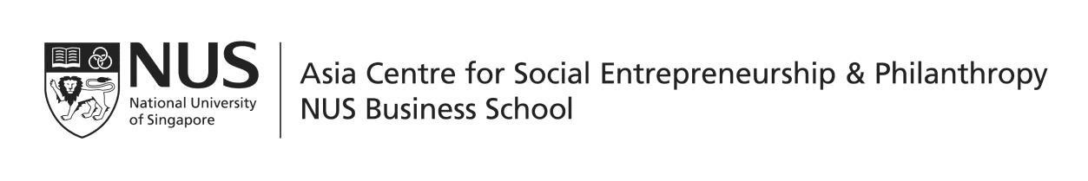

Application Form for NUS Business School Alumni Association (NUSBSA) Social Impact Prize Award – AY2018/19

Instructions:
1. Eligible applicants must:
a. Be full-time matriculated undergraduates (including honours students), attending one of
the following courses:
i. Bachelor of Business Administration/ Bachelor of Business Administration
(Honours);
ii. Bachelor of Business Administration (Accountancy)/ Bachelor of Business
Administration (Accountancy) (Honours);
iii. Double Degree Programme and Concurrent Degree Programme where the home faculty is the NUS Business School
b. Have achieved a minimum Cumulative Average Point (CAP) of 3.2

2. Please submit the following documents (as a PDF) together with the application form:
a. Your latest resume
b. At least one and up to three reference(s) from socially-driven organisation(s) (social enterprise, charity, VWO, or other) that you have worked with
c. One essay (maximum 500 words) which includes the following:
i. Description of your engagement/ contribution/ social impact in the
organisation(s) you have worked with; ii. Your motivations and takeaways;
iii. Evidence of personal qualities that strongly resonate with your pursuits

3. Please submit the complete set of entry materials in a folder (with your name as the folder name) to acsep@nus.edu.sg.

Submission deadline: 28 February 2019. Late submissions will be not considered.

Section A
Full Name (underline family name):
Matriculation Number:
Gender:
Nationality:
Date of Birth:
Postal Address:
NUS Email Address:
Contact Number:

Section B: Details of Engagement
Name of  Organisation | Period of  Engagement | Regularity (Daily,  Weekly, Monthly, Ad-Hoc) | Beneficiaries | Inputs (Specific Job  function and activities) | Output (Immediate  Benefits to Beneficiaries/ Organisations) | Outcome (Longer  Term Impact to Beneficiaries/ Organisations)

